Dynamic Pathfinding Agent Report
1. Introduction
This project implements a Dynamic Pathfinding Agent capable of navigating a grid-based environment using informed search algorithms. The system supports real-time obstacle spawning and automatic path re-planning.
The algorithms implemented are:
- A* Search
- Greedy Best First Search (GBFS)

2. Implementation Logic
2.1 Grid Representation
The environment is represented as a 2D grid using a list of lists.
- 0 → Empty cell
- 1 → Obstacle
- Start node → (0,0)
- Goal node → (Rows-1, Columns-1)
The user can:
- Define obstacle density
- Manually add or remove obstacles using mouse clicks

2.2 Heuristic Functions
Two heuristics were implemented:
- Manhattan Distance
h(n) = |x1 − x2| + |y1 − y2|
Used for 4-directional movement.
- Euclidean Distance
h(n) = √((x1 − x2)² + (y1 − y2)²)
The user selects the heuristic before running the search.

2.3 Greedy Best First Search (GBFS)
Evaluation function:
f(n) = h(n)
GBFS selects the node with the lowest heuristic value.
Implementation Details:
- Priority queue (heapq) used for frontier
- Only heuristic value considered
- Does not account for path cost from start
Behavior:
- Fast in simple environments
- May produce non-optimal paths

2.4 A* Search
Evaluation function:
f(n) = g(n) + h(n)
Where:
- g(n) = cost from start to node
- h(n) = heuristic estimate to goal
Implementation Details:
- Dictionary used to store g-cost
- Parent dictionary used to reconstruct path
- Priority queue used for node expansion
Behavior:
- Optimal when heuristic is admissible
- More balanced exploration compared to GBFS

2.5 Dynamic Obstacle Handling
When dynamic mode is enabled:
- At each time step, a new obstacle is added with small probability.
- If the new obstacle lies on the current path:
  - The search algorithm is re-executed.
  - A new path is computed from the current grid state.
This simulates real-world navigation with changing environments.

2.6 Visualization
Color coding:
- Start → Blue
- Goal → Purple
- Frontier nodes → Yellow
- Visited nodes → Red
- Final path → Green
- Obstacles → Black
Metrics displayed:
- Nodes visited
- Path cost
- Execution time (milliseconds)

3. Pros and Cons of Algorithms
3.1 Greedy Best First Search
Advantages:
- Fast in open environments
- Low computational overhead
- Simple evaluation function
Disadvantages:
- Not optimal
- Can get trapped in misleading paths
- May explore unnecessary regions in worst case

3.2 A* Search
Advantages:
- Optimal solution (with admissible heuristic)
- More balanced search
- Performs better in complex maps
Disadvantages:
- Higher memory usage
- Slightly slower than GBFS in simple maps

4. Experimental Findings
4.1 Best Case Scenario
Conditions:
- Low obstacle density (0.0 – 0.1)
- Straight path from start to goal
Observations:
- GBFS finds solution very quickly.
- A* also performs efficiently.
- Minimal node expansion.
(Insert Screenshot Here – A* Best Case)
(Insert Screenshot Here – GBFS Best Case)

4.2 Worst Case Scenario
Conditions:
- High obstacle density (0.4 – 0.5)
- Maze-like structure
- Dynamic mode enabled
Observations:
- GBFS explores large area and may produce longer path.
- A* expands more nodes but finds optimal path.
- Re-planning triggered multiple times in dynamic mode.
(Insert Screenshot Here – A* Worst Case)
(Insert Screenshot Here – GBFS Worst Case)

5. Conclusion
The project demonstrates how informed search algorithms behave in both static and dynamic environments.
Key conclusions:
- A* is more reliable and optimal.
- GBFS is faster in simple scenarios but unreliable in complex maps.
- Dynamic obstacle handling significantly increases computational complexity.
- Heuristic choice impacts performance and expansion pattern.

A* Search
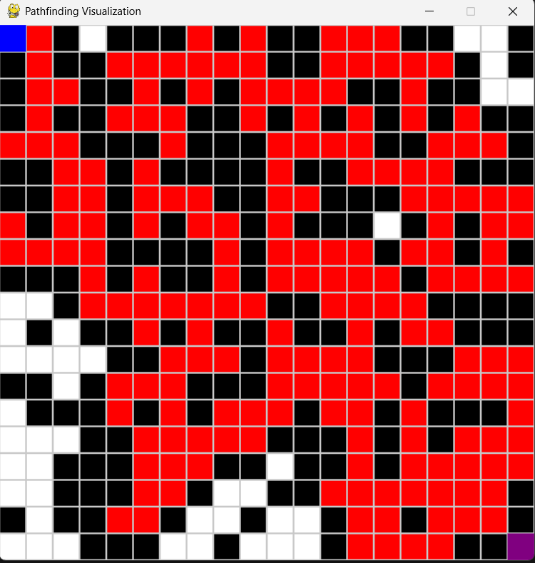

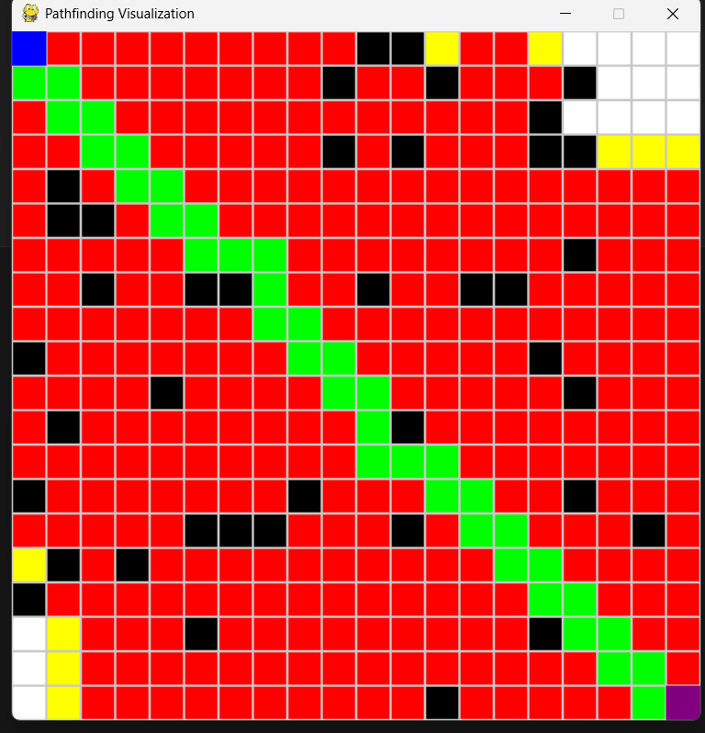

Greedy BFS
